**Tutorial 42: Vue Router – Lazy Loading Components**

In production, sometimes we might want to take the approach of lazy loading which allows us to minimise the overall bundle size of our production JavaScript so we can something called code splitting, whereby we only load components of JavaScript when we actually get to the route instead of loading all the JavaScript files all at once.

Make sure **Tutorial 41** is complete to be able to move on to this tutorial or clone the [vue3-firebase-course](https://github.com/younggrasshopperza/vue3-firebase-course) repository and go to branch called **Tutorial-41** and navigate to the young-grasshopper-jobs folder.

**Step 1:** In the router folder, in the index.js file, instead of importing a file, we could rather create a function which would execute when the user visits the route and then import a specific component.

Comment out the About component imported and remove the component in the route object and create the function that imports the component.

Look at the example below (**Line 3 and line 17**):

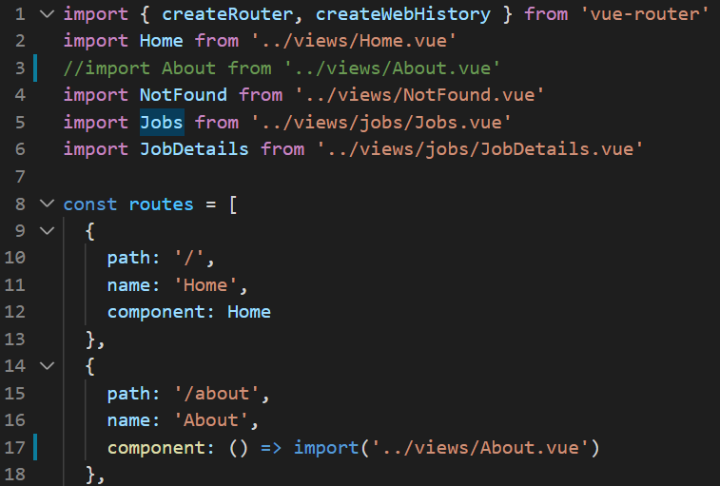

Reference: <https://router.vuejs.org/guide/advanced/lazy-loading.html>

**You can view the code snippets from the** [**vue3-firebase-course**](https://github.com/younggrasshopperza/vue3-firebase-course) **repository under the Tutorial-42 branch**.